Translational Grant 2020

Jointly funded by Action on Hearing Loss and Fondation Pour l’Audition

Call and guidelines
The Translational Grant aims to support and accelerate the translation of research discoveries into potential new treatments to protect and regenerate hearing and /or silence tinnitus. It funds projects at both academic institutions and small/medium enterprises in any country.

Action on Hearing Loss and Fondation Pour l’Audition are partnering to co-fund translational grants.

Why supporting the development of treatments for hearing loss and tinnitus is important?

There are almost half a billion people in the world with disabling hearing loss and 1.1 billion young people (aged between 12-35 years old) are at risk of losing their hearing due to recreational noise (WHO, 2018). The evidence of the link between hearing loss and debilitating conditions like dementia is strengthening (Livingston, G et al (2017) The Lancet). In the UK, one in ten people has tinnitus. However, there are currently no registered treatments that protect and/or restore hearing or silence tinnitus.

We request translational research proposals that will advance the development of small molecule, gene or cell-based therapeutics for the treatment of hearing disorders, including tinnitus.
We seek to support:
- research with a strong commercial potential that is likely to attract follow-on funding at the conclusion of the grant.
- studies that will facilitate and enable the progression of promising basic research towards testing in clinical trials.
Applications can include:
  - Studies which will enable lead optimisation and/or candidate selection.
  - Pharmacokinetics/Pharmacodynamics (PKPD) studies.
  - Safety/toxicology studies.
  - Drug repositioning/repurposing (applications must contain preliminary data supporting the proposed approach)
  - Validation of therapeutic targets for the treatment of hearing loss or tinnitus (applications must contain preliminary data supporting the proposed approach).
  - Studies to strengthen confidence that a target or therapeutic approach will be applicable to human hearing loss or tinnitus.
  - Identification/validation of methods or outcomes that could be used for one or more of the following*:
    - Patient selection/stratification for clinical trials
    - Robust measurement of treatment responses in clinical trials.
* Please note that these studies must support the development of a specific therapeutic. General research into outcome measures not aligned to a specific therapeutic should be submitted to other grant schemes of Action on Hearing Loss (e.g. Discovery Research Grant Scheme) and Fondation Pour l’ Audition.

Applications will NOT be accepted in the following areas:
- Basic research into the causes and underpinning biology of hearing loss and tinnitus
- The development of devices or software
- The optimization of current clinical protocols
- Health service studies

Summary of grant
- Duration: Up to three years
- Eligibility: Applicants may be from any country and may be from academic institutions and small/medium enterprises (SMEs)
- Value *: Up to £100,000 per year.
- Deadlines
  - Expression of Interest: 14th April 2020 (5 pm GMT)
  - Full application (by invitation only): 12th June 2020 (5 pm GMT)
  - Funding decisions: November/ December 2020
* Please note that as a charity, it is our policy not to fund any indirect costs or the salaries of permanent employees.

Application procedure

This grant application will follow a two stage process:
1. Expression of Interest - All applicants must submit an Expression of Interest. The purpose of the Expression of Interest is to obtain enough information on the proposed project to enable us to understand how well the proposal aligns with the criteria of the Translational scheme. Applicants with proposals meeting the criteria of the scheme will be invited to submit a full application.

2. Full Application - Applications that successfully complete the Expression of Interest stage will be invited to submit a Full Application.

Confidentiality
In order to protect the confidentiality of the information shared with us by the applicants everyone involved in the review process of any Translational grant application is asked to abide by our code of conduct and to sign a Reviewer Agreement with confidentiality clauses.

Overview of the application and selection procedure

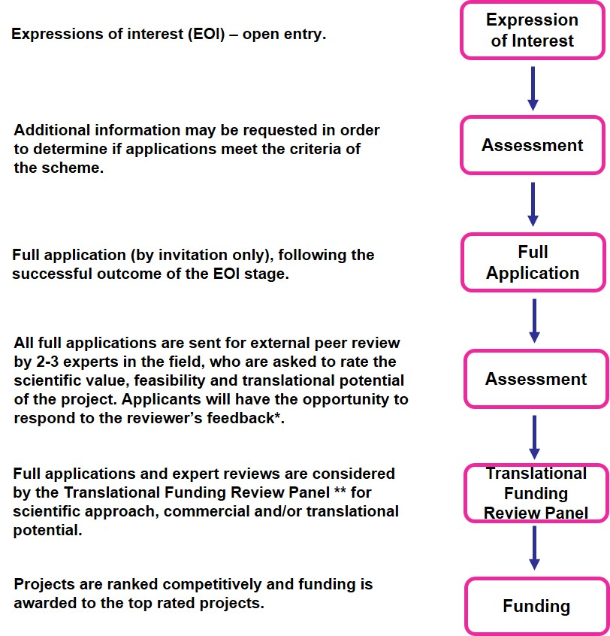

* At this stage abstracts are sent to the TRIH Research Partners (prior to this, applicants have the opportunity to list any TRIH Research Partners they do not wish to see their application). TRIH partners are not involved in the review process but have the opportunity to express interest in providing support to projects.

** TRIH Funding Review Panel
- Dr Rick Cousins (Cinnabar Consulting)
- Dr Paul England (IOTA Pharmaceuticals Ltd)
- Mr Freddie Dear (Syncona Investment Management Ltd)
- Dr Judith Langfield (Patient representative)
- Mr Peter Monksfield (University Hospitals Birmingham)
- Dr Louise Jones (UKRI MRC)
- Professor Marcelo Rivolta (University of Sheffield)
- Selected members of the Scientific Committee of the Fondation Pour l’Audition
(Additional panel members may be recruited)

